Catalogue

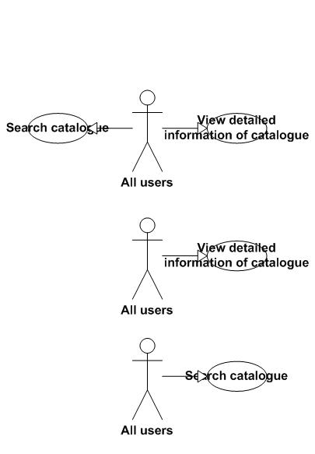

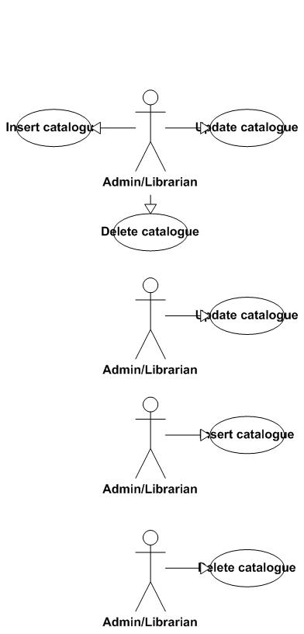



|  |  |  |
| --- | --- | --- |
| Use Case Name | Search catalogue of books | |
| Actors | All users | |
| Description | Search for some catalogues of books that are needed by users | |
| Requirement | Fields/Attributes must have validations on it | |
| Pre-conditions | Users must input keyword | |
| Post-conditions | A list of result will be display | |
| Basic Flow | Actor Actions:  1. Click “Search catalogue” button  3. User types keywords  4. Click "Search" button | System Response:  2. Display a search window form (in librarian management form) or a search page (in web form for readers)  5. A list of result will be displayed in users’ screens. If there is no result, will display “Sorry we can’t find the books you want.” |
| Exception Flow | N/A | |



|  |  |  |
| --- | --- | --- |
| Use Case Name | View detailed information of the catalogue of books | |
| Actors | All users | |
| Description | View detailed information of the catalogue of books | |
| Requirement | N/A | |
| Pre-conditions | User choose the catalogue which they want to view detailed information | |
| Post-conditions | Detailed information of catalogue will be displayed | |
| Basic Flow | Actor Actions:  1. In the result form of search page. User clicks “View detailed information” button | System Response:  2. Display a new window form (in win form mode) or new web page (in web mode) that includes the detailed information of the catalogue. |
| Exception Flow | N/A | |



|  |  |  |
| --- | --- | --- |
| Use Case Name | Insert catalogue of books | |
| Actors | Admin/Librarian | |
| Description | Insert a catalogue of books to the database | |
| Requirement | Fields/Attributes must have validations on it | |
| Pre-conditions | User must log in with role “Admin” or “Librarian” | |
| Post-conditions | New catalogue of books is added to database | |
| Basic Flow | Actor Actions:  1. Click “Add catalogue” button  3. User types required attributes  4. Click "Insert" button  6. User click “Yes” button | System Response:  2. Display a form and request to enter the attributes that will be processed.  5. Message box confirms "Are you sure to insert this catalogue?“.  7. Data will be checked and insert to the database. |
| Alternative Flow 1 | Actor actions:  1. Click “No” button | System Response:  2. Stay in the current window form. |
| Exception Flow | N/A | |



|  |  |  |
| --- | --- | --- |
| Use Case Name | Delete catalogue of books | |
| Actors | Admin/Librarian | |
| Description | Delete a catalogue of books to the database | |
| Requirement | Fields/Attributes must have validations on it | |
| Pre-conditions | User must log in with role “Admin” or “Librarian” | |
| Post-conditions | The available book field of catalogue of books will set to 0 and all the books in the same catalogue will be deleted from the database | |
| Basic Flow | Actor Actions:  1. In the result of search form or in the view detailed information form, user click “Delete” button.  3. User click “Yes” button | System Response:  2. Message box confirms "Are you sure to delete this catalogue and all the books belong to it? “.  7. The available book field in the database will set to 0 and all the books belong to it will be deleted from the database |
| Alternative Flow 1 | Actor actions:  1. Click “No” button | System Response:  2. Stay in the current window form. |
| Exception Flow | N/A | |



|  |  |  |
| --- | --- | --- |
| Use Case Name | Update catalogue of books | |
| Actors | Admin/Librarian | |
| Description | Update a catalogue of books to the database | |
| Requirement | Fields/Attributes must have validations on it | |
| Pre-conditions | User must log in with role “Admin” or “Librarian” | |
| Post-conditions | New data of catalogue is modified to database | |
| Basic Flow | Actor Actions:  1. In the result of search form or in the view detailed information form, user click “Edit” button.  3. User change the fields that they want to modify  4. Click "Edit" button  6. User click “Yes” button | System Response:  2. Display a form that has detailed information of catalogue and all the information appear in text box.  5. Message box confirms "Are you sure to change the information of this catalogue? “.  7. Data will be checked and updated to the database. |
| Alternative Flow 1 | Actor actions:  1. Click “No” button | System Response:  2. Stay in the current window form. |
| Exception Flow | N/A | |

Books:

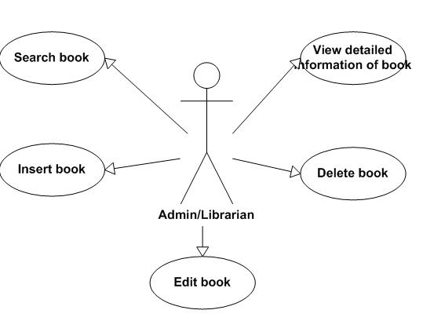

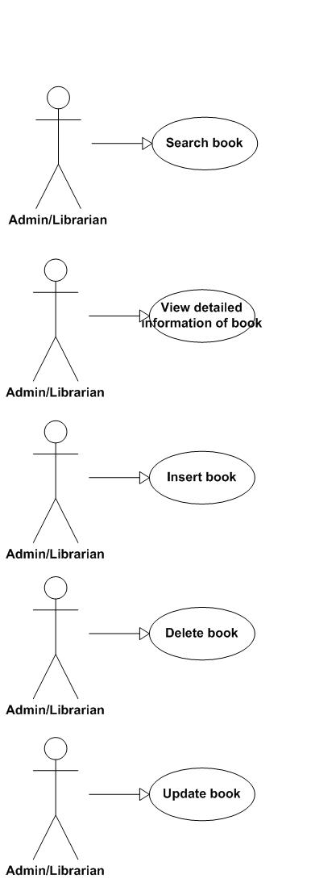

|  |  |  |
| --- | --- | --- |
| Use Case Name | Search book | |
| Actors | Librarian/Admin | |
| Description | Search for some catalogues of books that are needed by users | |
| Requirement | Fields/Attributes must have validations on it | |
| Pre-conditions | Users must input keyword | |
| Post-conditions | A list of result will be display | |
| Basic Flow | Actor Actions:  1. Click “Search book” button  3. User types keywords  4. Click "Search" button | System Response:  2. Display a search window form  5. A list of result will be displayed in users’ screens. If there is no result, will display “Sorry we can’t find the book you want.” |
| Exception Flow | N/A | |



|  |  |  |
| --- | --- | --- |
| Use Case Name | View detailed information of book | |
| Actors | Admin/Librarian | |
| Description | View detailed information of the book | |
| Requirement | N/A | |
| Pre-conditions | User choose the book which they want to view detailed information | |
| Post-conditions | Detailed information of book will be displayed | |
| Basic Flow | Actor Actions:  1. In the result form of search page. User clicks “View detailed information” button | System Response:  2. Display a new window form that includes the detailed information of the book. |
| Exception Flow | N/A | |



|  |  |  |
| --- | --- | --- |
| Use Case Name | Insert book | |
| Actors | Admin/Librarian | |
| Description | Insert books to the database | |
| Requirement | Fields/Attributes must have validations on it | |
| Pre-conditions | User must log in with role “Admin” or “Librarian” | |
| Post-conditions | New books is added to database | |
| Basic Flow | Actor Actions:  1. In the detailed catalogue information page, user click “Add book” button  3. User types required attributes or choose the number of books  4. Click "Insert" button  6. User click “Yes” button | System Response:  2. Display a form and request to enter the attributes that will be processed (with separate book) or the number of books that they want to add to the catalogue.  5. Message box confirms "Are you sure to insert book? “.  7. Data will be checked and insert to the database. |
| Alternative Flow 1 | Actor actions:  1. Click “No” button | System Response:  2. Stay in the current window form. |
| Exception Flow | N/A | |



|  |  |  |
| --- | --- | --- |
| Use Case Name | Delete book | |
| Actors | Admin/Librarian | |
| Description | Delete a book from the database | |
| Requirement | Fields/Attributes must have validations on it | |
| Pre-conditions | User must log in with role “Admin” or “Librarian” | |
| Post-conditions | book will be deleted from the database | |
| Basic Flow | Actor Actions:  1. In the result of search form or in the view detailed information form, user click “Delete” button.  6. User click “Yes” button | System Response:  2. Message box confirms "Are you sure to delete this book? “.  7. The selected book will be deleted from the database |
| Alternative Flow 1 | Actor actions:  1. Click “No” button | System Response:  2. Stay in the current window form. |
| Exception Flow | N/A | |



|  |  |  |
| --- | --- | --- |
| Use Case Name | Update a book | |
| Actors | Admin/Librarian | |
| Description | Update a information of a book to the database | |
| Requirement | Fields/Attributes must have validations on it | |
| Pre-conditions | User must log in with role “Admin” or “Librarian” | |
| Post-conditions | New data of book is modified to database | |
| Basic Flow | Actor Actions:  1. In the result of search form or in the view detailed information form, user click “Edit” button.  3. User change the fields that they want to modify  4. Click "Edit" button  6. User click “Yes” button | System Response:  2. Display a form that has detailed information of book and all the information which user can modify is appeared in text box.  5. Message box confirms "Are you sure to change the information of this catalogue?“.  7. Data will be checked and updated to the database. |
| Alternative Flow 1 | Actor actions:  1. Click “No” button | System Response:  2. Stay in the current window form. |
| Exception Flow | N/A | |

Category

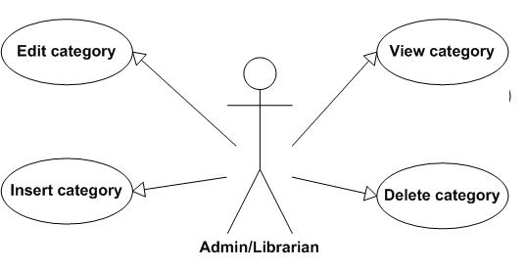

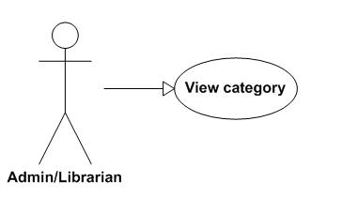

|  |  |  |
| --- | --- | --- |
| Use Case Name | View category | |
| Actors | Admin/Librarian | |
| Description | View detailed information of category | |
| Requirement | N/A | |
| Pre-conditions | User choose the category which they want to view detailed information | |
| Post-conditions | Detailed information of category will be displayed | |
| Basic Flow | Actor Actions:  1. In the result form of search page. User clicks “View detailed information” button | System Response:  2. Display a new window form that includes the detailed information of the category. |
| Exception Flow | N/A | |

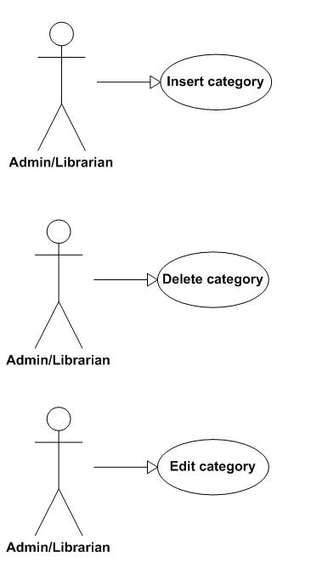

|  |  |  |
| --- | --- | --- |
| Use Case Name | Insert category of books | |
| Actors | Admin/Librarian | |
| Description | Insert a category of books to the database | |
| Requirement | Fields/Attributes must have validations on it | |
| Pre-conditions | User must log in with role “Admin” or “Librarian” | |
| Post-conditions | New category of books is added to database | |
| Basic Flow | Actor Actions:  1. Click “Add category” button  3. User types required attributes  4. Click "Insert" button  6. User click “Yes” button | System Response:  2. Display a form and request to enter the attributes that will be processed.  5. Message box confirms "Are you sure to insert this category? “.  7. Data will be checked and insert to the database. |
| Alternative Flow 1 | Actor actions:  1. Click “No” button | System Response:  2. Stay in the current window form. |
| Exception Flow | N/A | |



|  |  |  |
| --- | --- | --- |
| Use Case Name | Delete category of books | |
| Actors | Admin/Librarian | |
| Description | Delete a category of books from the database | |
| Requirement | Fields/Attributes must have validations on it | |
| Pre-conditions | User must log in with role “Admin” or “Librarian” | |
| Post-conditions | The category will be delete from the database and all the catalogue that referenced to this category will be referenced to the parent category or set to uncategorized | |
| Basic Flow | Actor Actions:  1. In the result of search form or in the view detailed information form, user click “Delete” button.  3. User click “Yes” button | System Response:  2. Message box confirms "Are you sure to delete this category? “.  7. The category will be delete from the database and all the catalogue that referenced to this category will be referenced to the parent category or set to uncategorized |
| Alternative Flow 1 | Actor actions:  1. Click “No” button | System Response:  2. Stay in the current window form. |
| Exception Flow | N/A | |



|  |  |  |
| --- | --- | --- |
| Use Case Name | Update category of books | |
| Actors | Admin/Librarian | |
| Description | Update a category of books to the database | |
| Requirement | Fields/Attributes must have validations on it | |
| Pre-conditions | User must log in with role “Admin” or “Librarian” | |
| Post-conditions | New data of category is modified to database | |
| Basic Flow | Actor Actions:  1. In the result of search form or in the view detailed information form, user click “Edit” button.  3. User change the fields that they want to modify  4. Click "Edit" button  6. User click “Yes” button | System Response:  2. Display a form that has detailed information of category and all the information appear in text box.  5. Message box confirms "Are you sure to change the information of this category? “.  7. Data will be checked and updated to the database. |
| Alternative Flow 1 | Actor actions:  1. Click “No” button | System Response:  2. Stay in the current window form. |
| Exception Flow | N/A | |